Payroll Management System for Information Technology Company

**Business Use-Case Specification: Add employee**

Version 1.0

**Table of Contents**

1. Introduction

1.1. Purpose

1.2. Scope

1.3. Definition

1.4. References

1.5. Overview

2. Business Use-Case Name

2.1. Brief Description

3. Goals

4. Perfomance Goals

5. Workflow

5.1. Basic Workflow

6. Risk

7. Possibilities

8. Process Owner

9. Special Requirements

10. Extension Points

**Business Use-Case Specification: Add Employee**

1. **Introduction**
   1. Purpose

The purpose of this business use-case is to show how the admin deals with the situation when the company has a new employee.

* 1. Scope

The scope of this business use-case is associated with the Payroll management system to be deployed.

* 1. Definiton, Acronyms, and Abbreviations
  2. References
  3. Overview

The rest of Business Use-Case Specificationcontains Goals, Perfomance Goals, Workflow, Risk, Possibilities, Process Owner, Special Requirements, Extension Points.

1. **Business Use-case Name**
   1. Brief Description

The use-case here is “add”, which means in this situation the admin add an employee information to the system.

1. **Goals**

The goal of the business use-case is to add an new employee.

1. **Performance Goals**

No special.

1. **Workflow**
   1. Basic Workflow

When the employee join the company, the admin input their information and send a add request to the system. The system recieves the information and save the information to the system database.

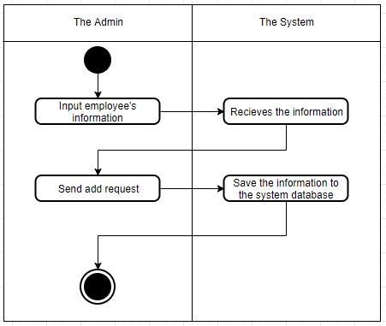

1. **Risk**

No special.

1. **Possibilities**

No special.

1. **Process Owner**

The process owner of this use-case is the admin which deals with the situation when the company has a new employee.

1. **Special Requirements**

No special.

1. **Extension Point**

No extension point.